Steps To Configure Selenium Baby Framework-III

- Add BABYFRAMEWORK-III in Eclipse(Download “BABYFRAMEWORK-III” from Github.com)
https://github.com/SenthilKumarSelenium/SeleniumBabyFramework-III
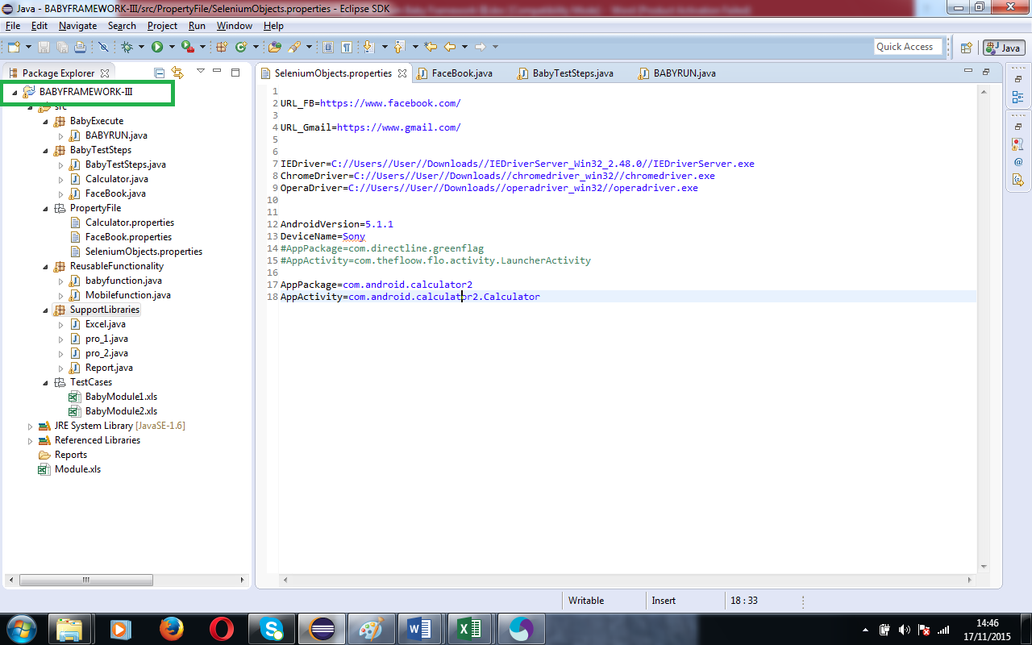
- Add below Jar files
- Selenium Jars
http://selenium-release.storage.googleapis.com/2.48/selenium-java-2.48.2.zip
- Java-client jar(Appium Jar)
http://mvnrepository.com/artifact/io.appium/java-client/3.2.0
- Jxl.jar
http://mirrors.ibiblio.org/pub/mirrors/maven/net.sourceforge.jexcelapi/jars/jxl-2.6.jar

- Open “Module.xls” and Add one new module(BabyModule2) and make the status as ACTIVE
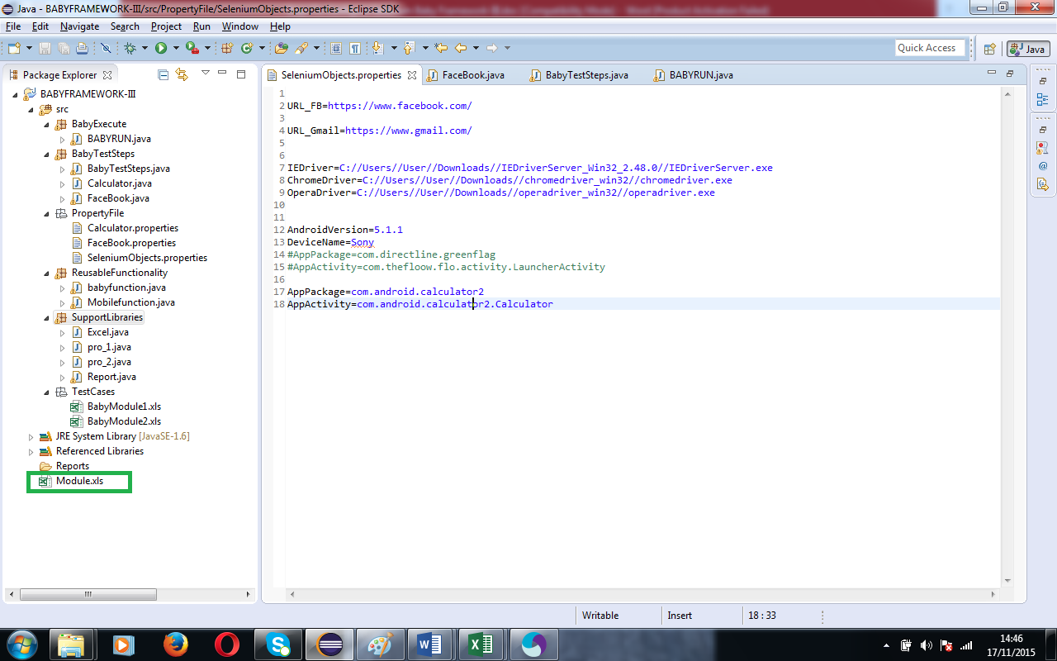

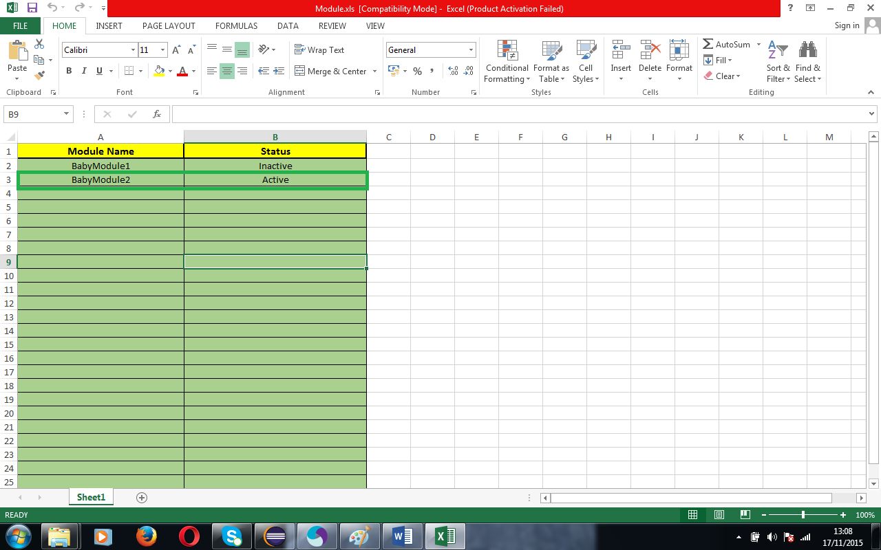
- Add “BabyModule2.xls” Under “TestCaess” Package

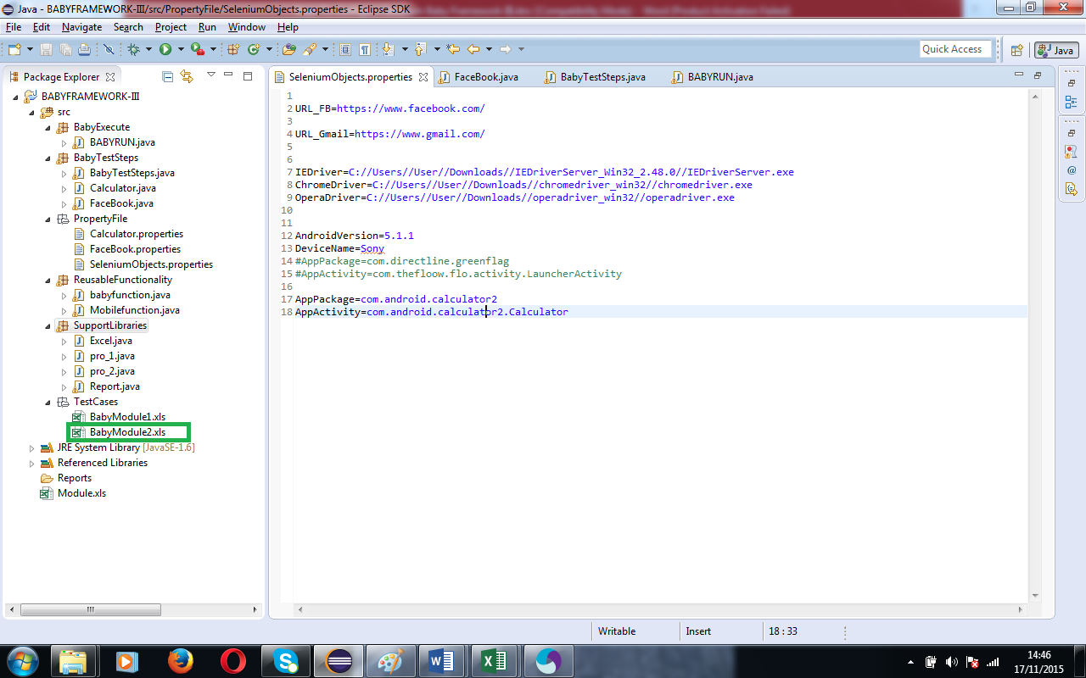

- Open “BabyModule2.xls” and your business components
- TC ID- Unique ID for the Testcases
- Active/Inactive— Active row Testcases only taken during execution
- Browser – This column configure with “SeleniumObjects.properties”. Make sure that give the correct driver path(Chrome,IE,Opera Driver). For appium make sure that give the correct Apppackage and Appactivity.
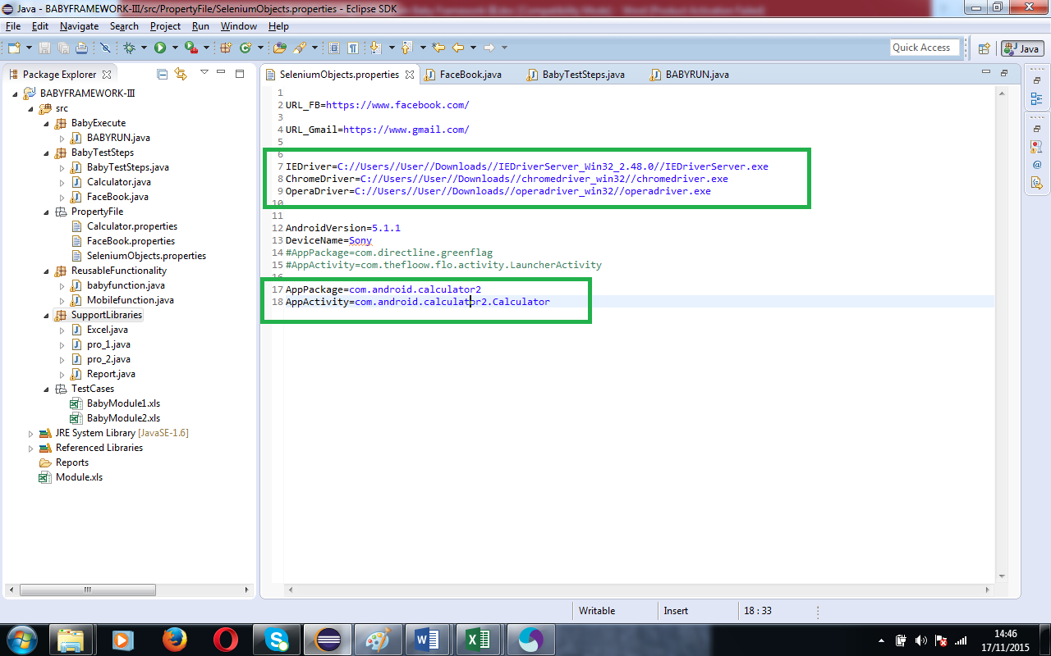
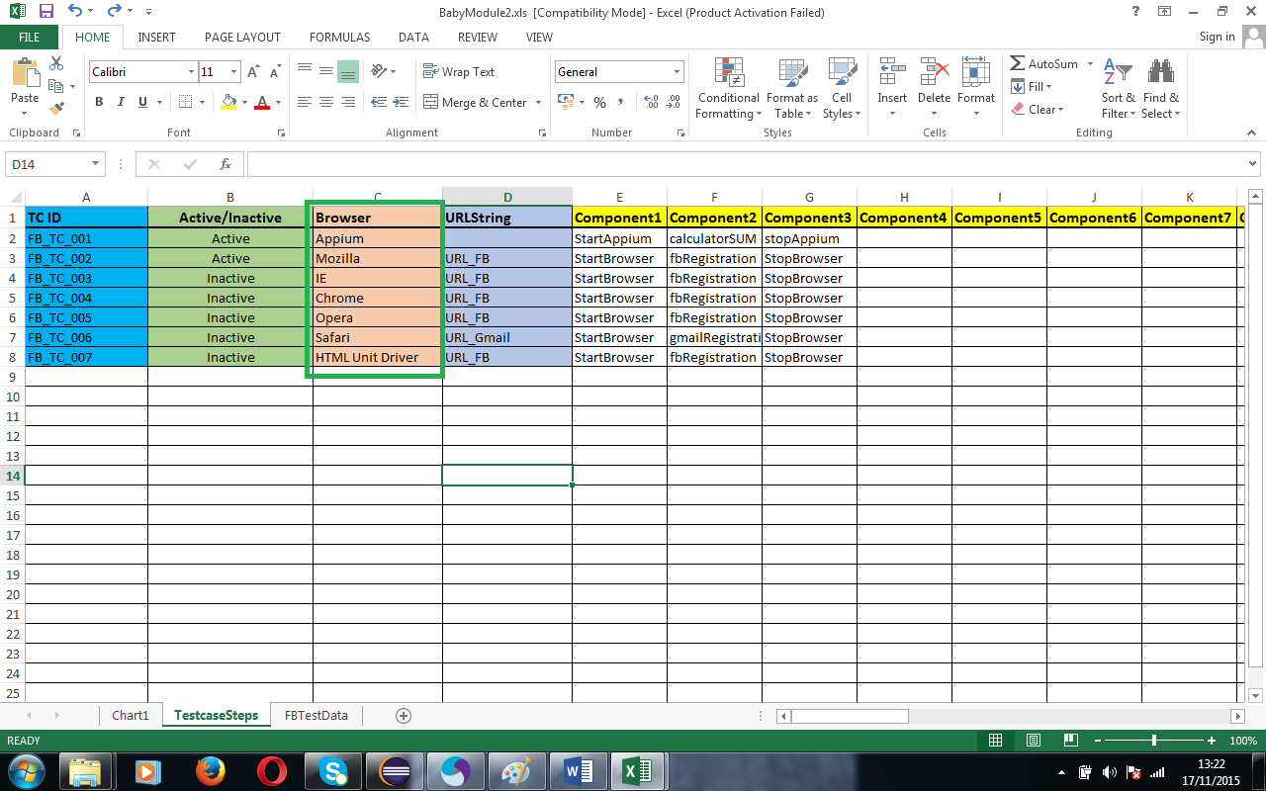
- URL STRING—This column is configure with “SeleniumObjects.properties”
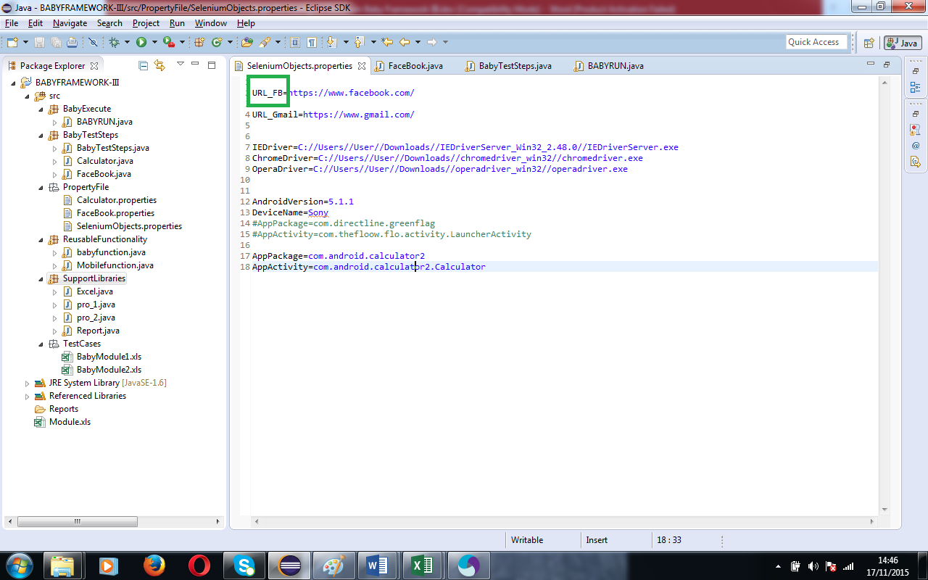
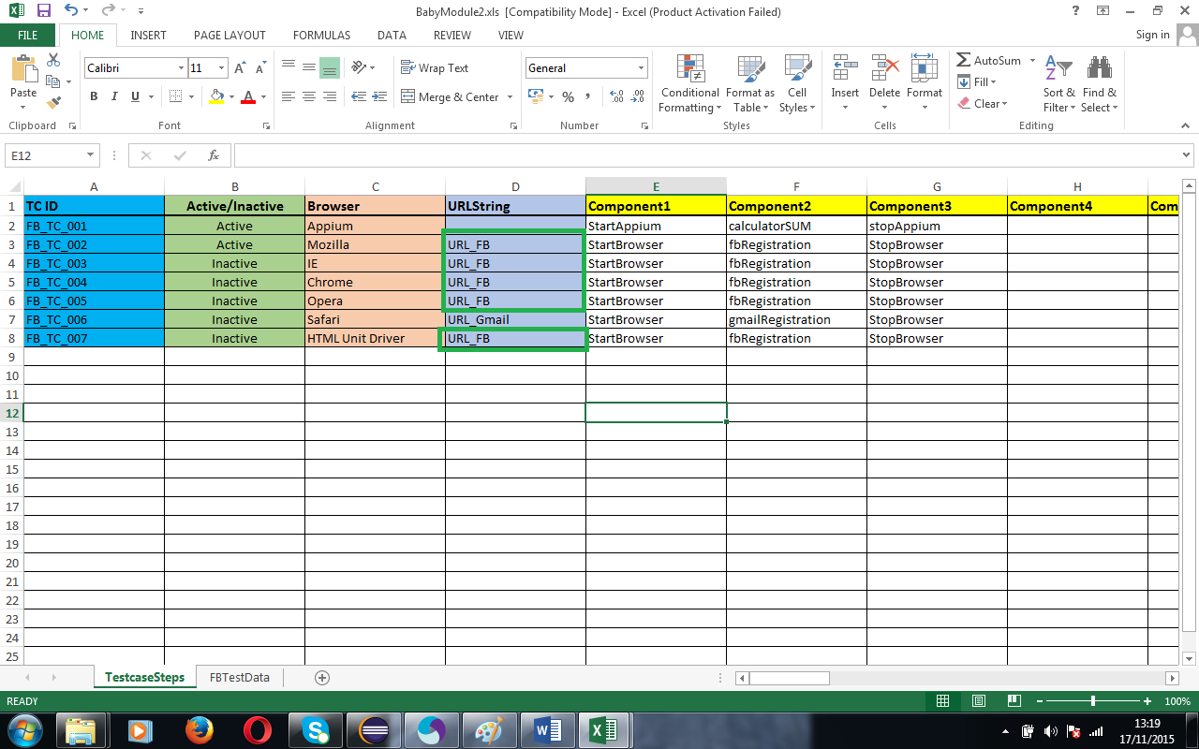

- Business Component –(Componet1, Component2 etc.,)
- Webapplication— StartBrowser and StopBrowser Components are mandatory and rest of the components we can create it in “BabyTestSteps.java” file
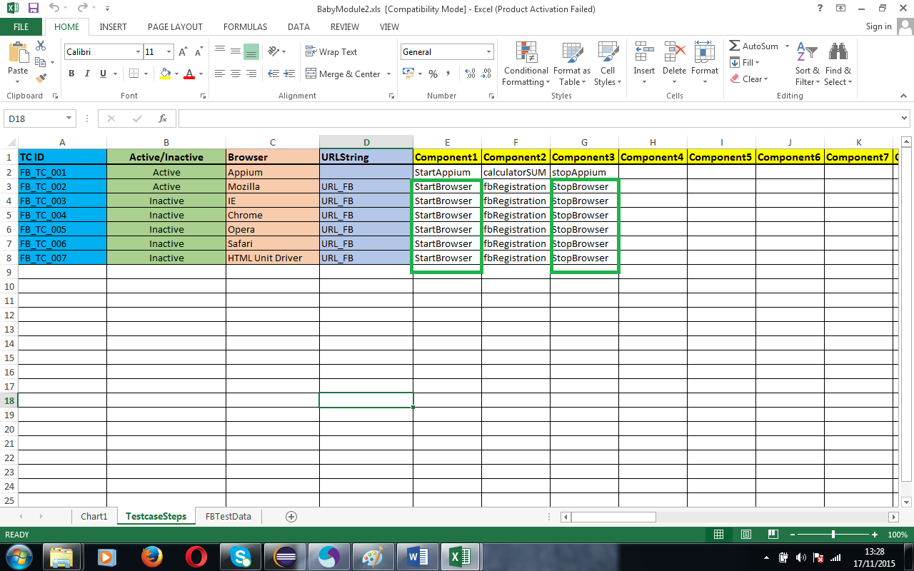
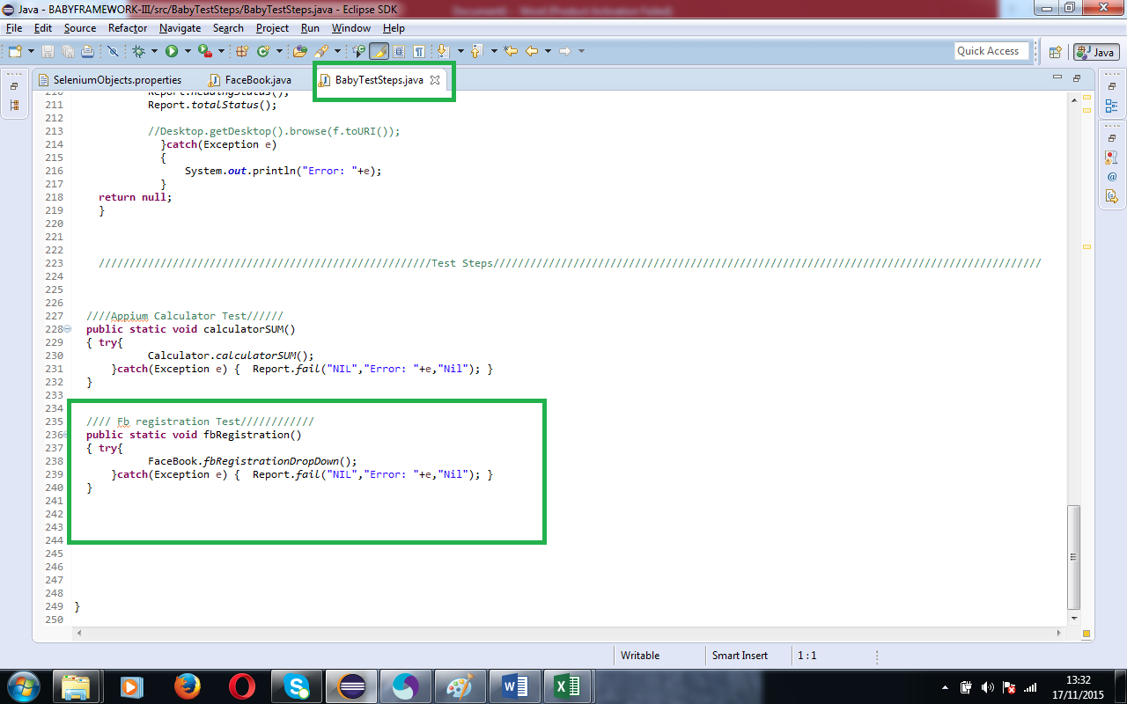
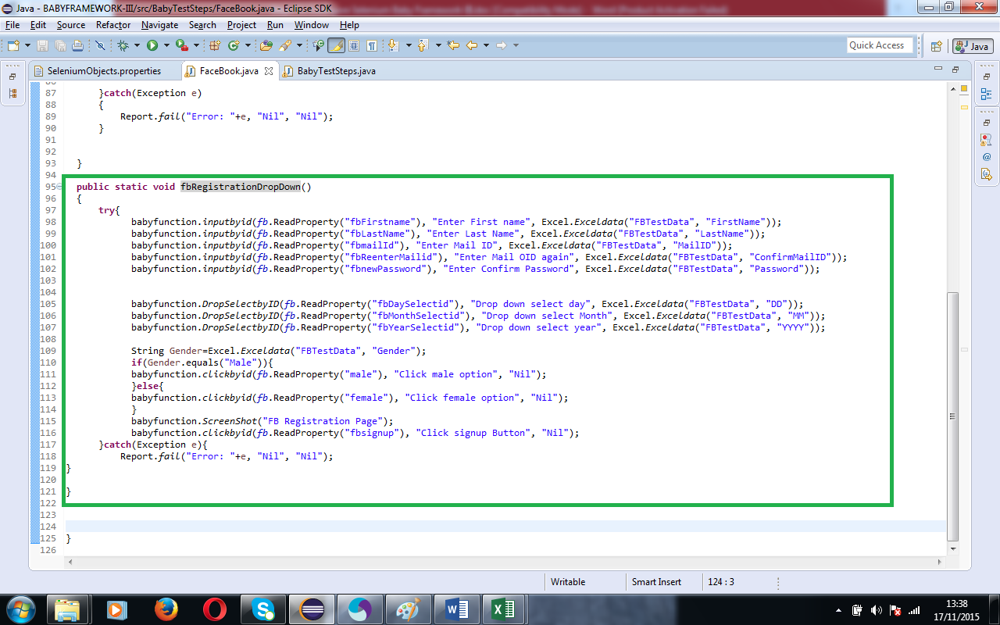

- MobileApplication— StartAppiun and StopAppium components are mandatory and rest of the components we can create it in “BabyTestSteps.java” file

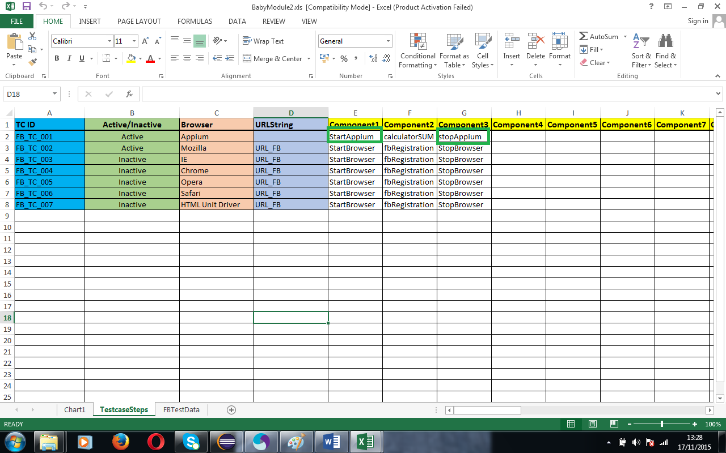
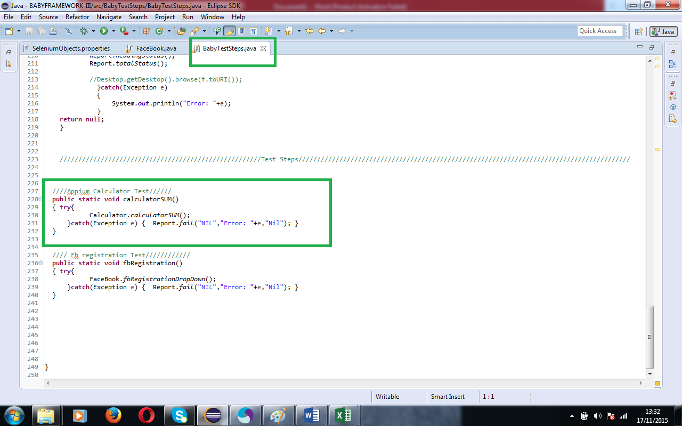
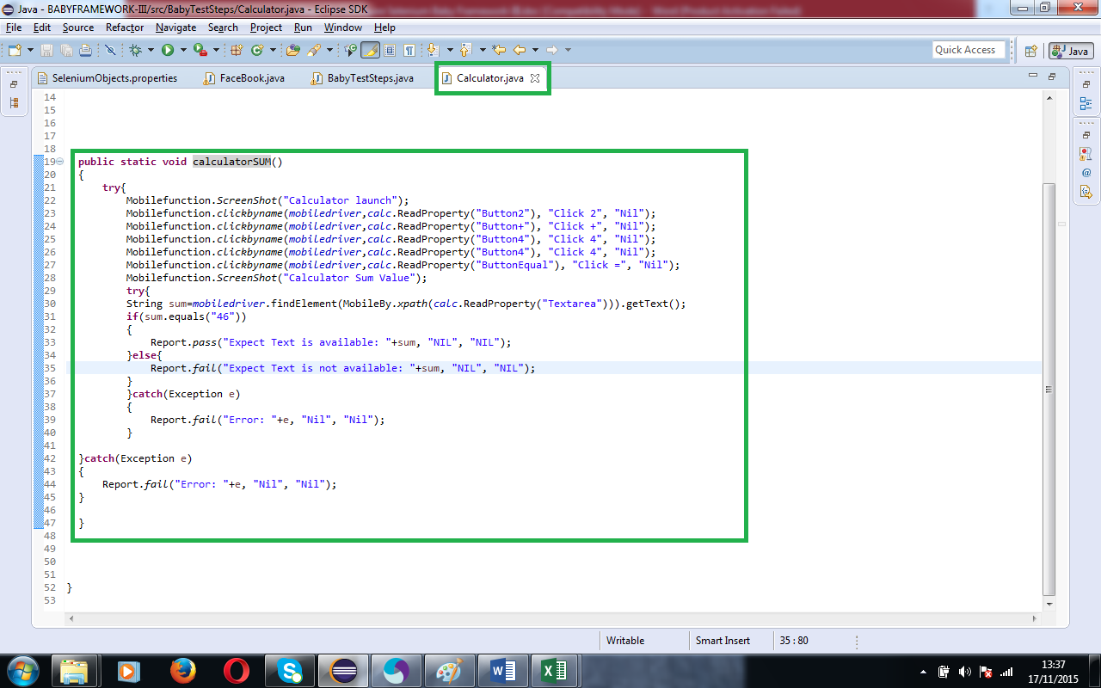
- Add any no.of test data sheet in the same “BabyModule2.xls” – Syntax to get the cell value is: Excel.Exceldata("FBTestData", "FirstName")
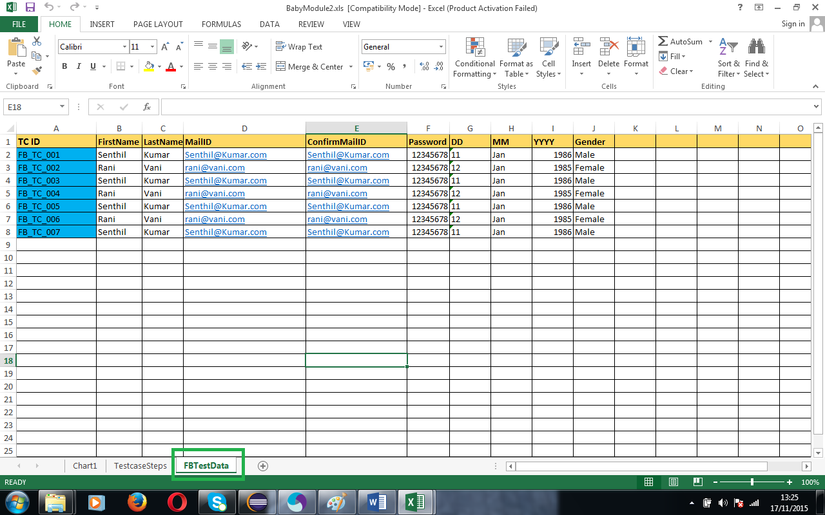

- Execute “BabyRun.java” once the execution done, the report will be stored in report package.
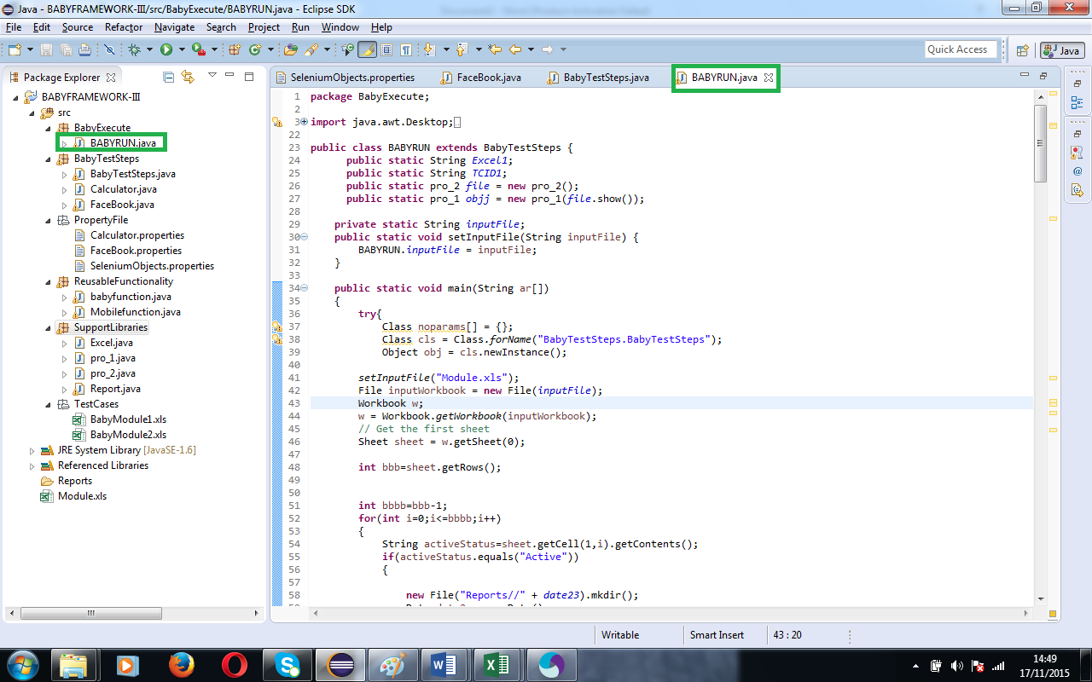
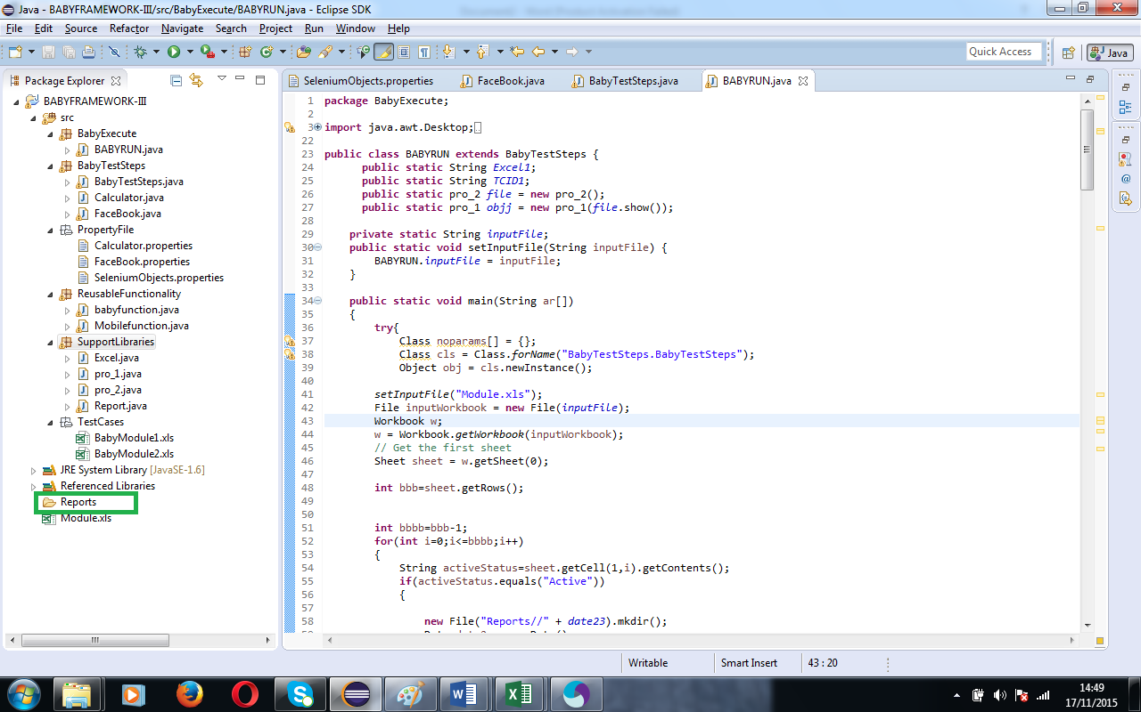

- Below is the same execution sample report for Mobile and Web Application.

